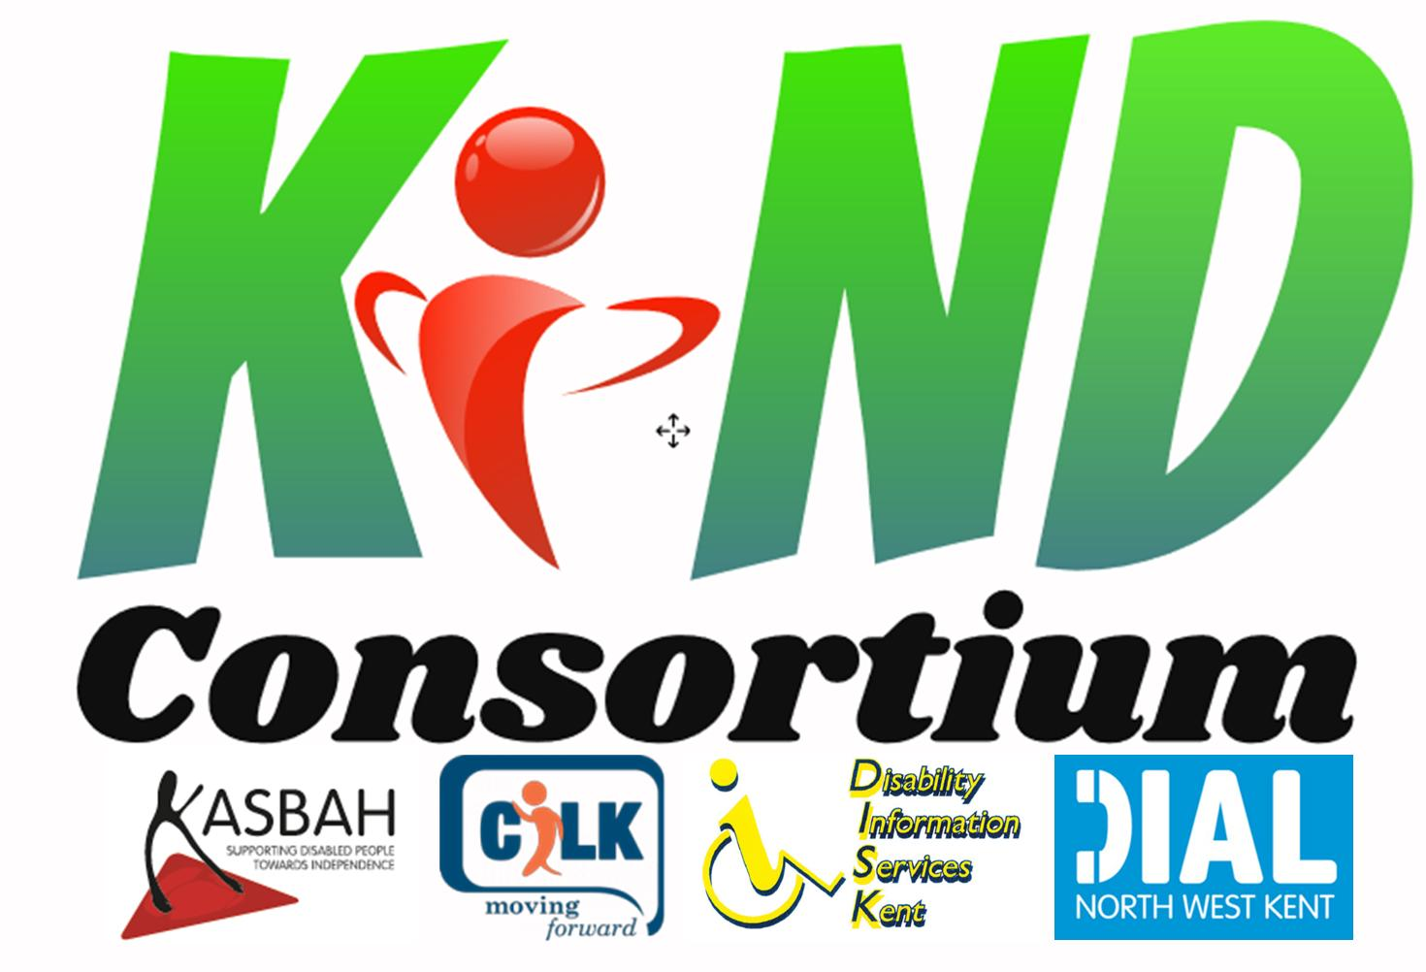
Personal (2018/19) Independence Payment –
How your disability affects you.

The care component of PIP can be paid at two levels. To get the Standard rate your ability to carry out care activities must be limited by your physical or mental condition; and you meet the required qualifying period of 3 months prior to making your claim and feel that it will last 9 months past the date that you claim. To qualify for the Enhanced rate of care your ability to carry out care activities must be severely limited by your physical or mental health and you meet the required qualifying period as above. Your ability to carry out care activities is assessed by looking at the way that you carry out daily living activities safely, to an acceptable standard, repeatedly and in a reasonable time period.

Within these activities there is a list of descriptors with scores ranging from 0 – 12 points. You score points when you are not able to complete a task described safely, to an acceptable standard, repeatedly and in a reasonable time period. If more than one descriptor applies to you only the high one counts in each activity.

To be entitled to the Standard rate of care you need to score at least 8 points, for the Enhanced rate 12 points. These points can come from more than one descriptor.

Standard rate care pays £55.65 per week and the Enhanced rate is £83.10 per week.

Preparing food.
- Can prepare and cook a simple meal unaided. Points 0
- Needs to use an aid or appliance to be able to either prepare or cook a simple meal. Points 2
- Cannot cook a simple meal using a conventional cooker but is able to do so using a microwave. Points 2
- Needs prompting to be able to either prepare or cook a simple meal. Points 2
- Needs supervision or assistance to either prepare or cook a simple meal. Points 4
- Cannot prepare or cook food. Points 8

Taking nutrition.
- Can take nutrition unaided. Points 0
- Needs – (i) to use an aid or appliance to be able to take nutrition; or (ii) supervision to be able to take nutrition; or (iii) assistance to be able to cut up foods. Points 2
- Needs a therapeutic source to be able to take nutrition. Points 2
- Needs prompting to be able to take nutrition. Points 4
- Needs assistance to be able to manage a therapeutic source to take nutrition. Points 6
- Cannot convey food or drink to their mouth and needs another person to do so. Points 10

Managing therapy or monitoring a health condition.
- Either- (i) does not receive medication or therapy or (ii) can manage medication or therapy or monitor a health condition unaided. Points 0
- Needs either – (i) to use an aid or appliance to be able to manage medication; or (ii) supervision, prompting or assistance to be able to manage medication or monitoring a health condition. Points 1
- Needs supervision, prompting or assistance to be able to manage therapy that takes no more than 3.5 hours a week. Points 2
- Needs supervision, prompting or assistance to be able to manage therapy that takes more than 3.5 but no more than 7 hours a week. Points 4
- Needs supervision, prompting or assistance to be able to manage therapy that takes more than 7 but no more than 14 hours a week. Points 6
- Needs supervision, prompting or assistance to be able to manage therapy that takes more than 14 hours a week. Points 8

Washing and bathing.
- Can wash and bathe unaided. Points 0
- Needs to use an aid or appliance to be able to wash or bathe. Points 2
- Needs supervision to be able to wash or bathe. Points 2
- Need supervision or prompting to be able to wash either their hair or body below the waist. Points 2
- Needs assistance to be able to get in or out of the bath or shower. Points 3
- Needs assistance to be able to wash their body between the shoulders and waist. Points 4
- Cannot wash and bathe at all and needs another person to wash their entire body. Points 8

Managing toilet needs or incontinence.

- Can manage toilet needs or incontinence unaided. Points 0
- Needs to use an aid or appliance to be able to manage toilet needs or incontinence. Points 2
- Needs supervision or prompting to be able to manage toilet needs. Points 2
- Needs assistance to be able to use the toilet. Points 4
- Needs assistance to be able to manage incontinence of either bladder or bowel. Points 6
- Needs assistance to be able to manage incontinence of both bladder and bowel. Points 8

Dressing and undressing.

- Can dress and undress unaided. Points 0
- Needs to use an aid or appliance to be able to dress or undress. Points 2
- Needs either – (i) prompting to be able to dress, undress or determine appropriate circumstances for remaining clothed; or (ii) prompting or assistance to be able to select appropriate clothing. Points 2
- Needs assistance to be able to dress or undress the lower body. Points 2
- Needs assistance to be able to dress or undress the upper body. Points 4
- Cannot dress or undress at all. Points 8

Communicating verbally.

- Can express and understand verbal communication unaided. Points 0
- Needs to use an aid or appliance to be able to speak or hear. Points 2
- Needs communication support to be able to express or understand complex verbal information. Points 4
- Needs communication support to express or understand basic verbal information. Points 8
- Cannot express or understand verbal information at all even with communication support. Points 12

Reading and understanding signs, symbols and words.

- Can read and understand basic and complex written information either unaided or using spectacles or contact lenses. Points 0
- Need to use an aid or appliance other than spectacles or contact lenses, to be able to read or understand either basic or complex written information. Points 2
- Needs prompting to be able to read or understand complex written information. Points 2
- Needs prompting to be able to read or understand basic written information. Points 4
- Cannot read or understand signs, symbols or words at all. Points 8

Engaging with other people face to face.

- Can engage with other people unaided. Points 0
- Needs prompting to be able to engage with other people. Points 2
- Needs social support to be able to engage with other people. Points 4
- Cannot engage with other people due to such engagement causing either – (i) overwhelming psychological distress to the claimant; or (ii) the claimant to exhibit behaviour which would result in a substantial risk of harm to the claimant or another person. Points 8

Making budgeting decisions.

- Can manage complex budgeting decisions unaided. Points 0
- Needs prompting or assistance to be able to make complex budgeting decisions. Points 2
- Needs prompting or assistance to be able to make simple budgeting decisions. Points 4
- Cannot make any budgeting decision. Points 6

If you suffer from a terminal illness you will need to meet the required points award to qualify for the enhanced award. At the time of making your first contact call if you state that you are making your claim under “special rules” you will be asked about your condition. All special rules claim must be supported by a DS1500 certificate from your doctor or consultant stating that your death ‘can reasonably be expected’ within the next six months. A decision will be made within eight working days for DS1500 claims.

The mobility component of PIP can be paid at two levels. To get the Standard rate your ability to carry out mobility activities must be limited by your physical or mental condition; and you meet the required qualifying period of 3 months prior to making your claim and feel that it will last 9 months past the date that you claim. To qualify for the Enhanced rate of mobility your ability to carry out mobility activities must be severely limited by your physical or mental health and you meet the required qualifying period as above. Your ability to carry out mobility activities is assessed by looking at two types of activity, these are:- 1. Planning and following journeys; 2. Moving around.

Within both of these activities there is a list of descriptors with scores ranging from 0 – 12 points. You score points when you are not able to complete a task described safely, to an acceptable standard, repeatedly and in a reasonable time period. If more than one descriptor applies to you only the high one counts in each activity.

To be entitled to the Standard rate of mobility you need to score at least 8 points, for the Enhanced rate 12 points. These points can come from more than one descriptor.

Standard rate of mobility pays £22.00 per week and the enhanced rate £58.00 per week.

Planning and following a journey. The questions in this category tend to be aimed at people with learning difficulties, mental health issues or sensory impairments such as visual loss. This will become clearer when you look at the activities and points shown below.

- Can plan and follow the route of a journey unaided. Points 0
- Needs prompting to be able to undertake any journey to avoid overwhelming psychological distress to the claimant. Points 4
- Cannot plan the route of a journey. Points 8
- Cannot follow the route of an unfamiliar journey without another person, assistance dog or orientation aid. Points 10
- Cannot undertake any journey because it would cause overwhelming psychological distress to the claimant. Points 10
- Cannot follow the route of a familiar journey without another person, an assistance dog or an orientation aid. Points 12

Moving around. These questions look at the amount of physical pain, discomfort, fatigue or breathlessness that you have due to your disabilities.

- Can stand and then move more than 200 metres either aided or unaided. Points 0
- Can stand and then move more than 50 metres but not more than 200 metres either aided or unaided. Points 4
- Can stand and then move unaided more than 20 metres but less than 50 metres.
Points 8
- Can stand and then move using an aid or appliance more than 20 metres but no more 50 metres. Points 10
- Can stand and then move more than 1 metre but no more than 20 metres either aided or unaided. Points 12
- Cannot either aided or unaided stand or move more than 1 metre. Points 12
When thinking about the mobility questions do not forget that this includes your mobility indoors i.e. getting out of a chair, moving around indoors, climbing/descending stairs etc.

Unlike the care component there is no fast track to a mobility award under terminal illness rules. If you suffer from a terminal illness you will need to meet the required points award to qualify for the standard or enhanced mobility award. At the time of making your first contact call if you state that you are making your claim under “special rules” you will be asked about your mobility, this may speed up the decision on whether you are entitled to mobility as well as the care component. All special rules claim must be supported by a DS1500 certificate from your doctor or consultant stating that your death ‘can reasonably be expected’ within the next six months. A decision will be made within eight working days for DS1500 claims.

As with any other state benefit you have the right to appeal if you have been turned down for the mobility award or you feel that the award has been made at the wrong rate. You have four weeks in which to appeal from the date shown on the notification letter. If you require help with your appeal it is strongly recommended that you contact us sooner rather than later as our diary is often full for weeks rather than days ahead.

The PIP mobility award differs from DLA mobility with regard to the Road Tax Exemption (VED). Under PIP if you are in receipt of the Enhanced rate of mobility you are entitled to the full 100% exemption of Road Tax. If you are in receipt of the Standard rate of mobility you can now get a 50% reduction of your Road Tax.

Qualification for a Blue Badge has also changed and for new claimants using PIP as the route to their badge you must have been awarded 8 points or more in the “moving around” descriptor. As under the DLA rules you may also qualify for a Blue Badge if you have a permanent and substantial disability that affects your mobility. In Kent you may be asked to attend an assessment centre so they can look at the severity of your mobility problems.

As with any other state benefit you have the right to appeal if you have been turned down for the care award or you feel that the award has been made at the wrong rate. You have four weeks in which to appeal from the date shown on the notification letter. If you require help with your appeal it is strongly recommended that you contact us sooner rather than later as our diary is often full for weeks rather than days ahead.

If you require help with any of the questions or filling out the claim form please do not hesitate to contact us. We will either give you the information over the phone or make an appointment for you to come into the office. If filling out the form you only have four weeks to return it to the DWP unlike the six weeks previously allowed under DLA rules. It is important that you contact us as soon as possible due to the high demand that we have on our service and time available.

